FP GREEN 24 PSI vs FP RED 18 PSI Power only

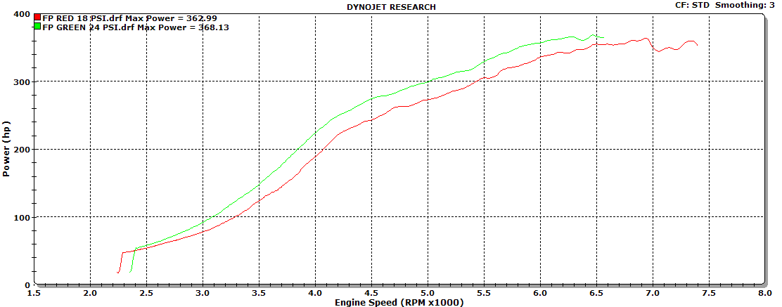

FP RED 18 PSI vs FP GREEN 24 PSI Power and torque

