FP RED 18 PSI Power Only

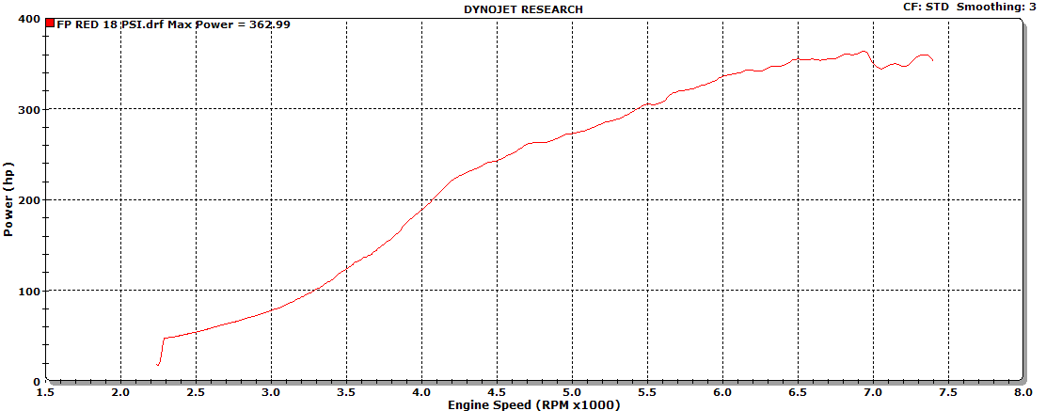

FP RED 18 PSI Power and Torque
