FP RED 24 PSI vs FP GREEN 24 PSI Power only

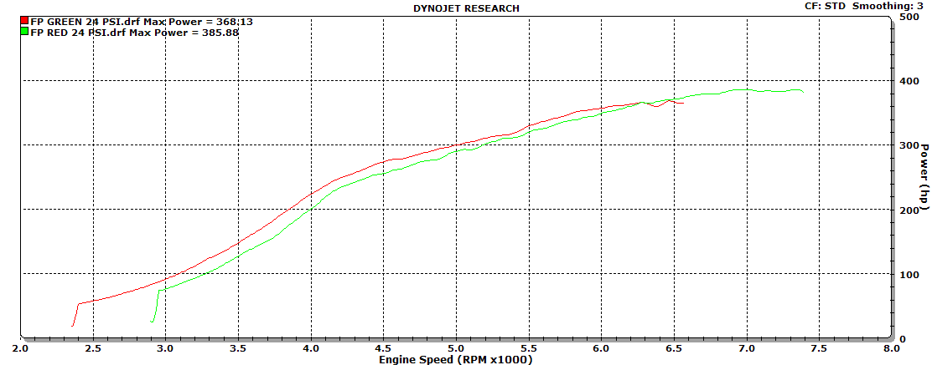

FP RED 24 PSI vs FP GREEN 24 PSI Power and Torque

