FP RED 28 PSI vs FP GREEN 30 PSI Power only

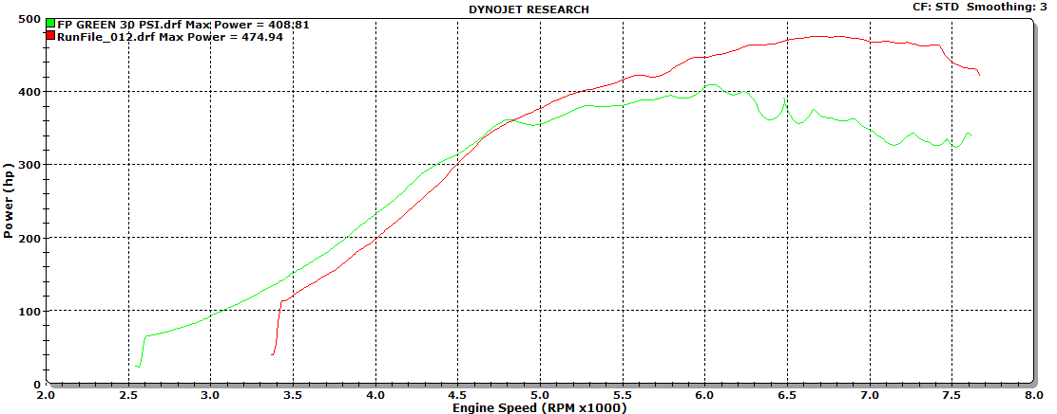

FP RED 28 PSI vs FP GREEN 30 PSI Power and torque

